**Chicago Restaurant Business Location Selection Analysis**

1. **Introduction**
   1. **Description & Discussion of the Background**

Chicago is the most popular city in the U.S. state of Illinois and the third most populous city in the United States. With 77 communities and an estimated population of 2,705,994 (2018), it is also the most populous city in the [Midwestern United States](https://en.wikipedia.org/wiki/Midwestern_United_States) [1]. So, there are hundreds and thousands of business opportunities waiting for us to explore.

This project aims to give a big picture about where to start your restaurant business, based on the analysis from average community population, average community income and existing restaurant locations aspects.

**1.2 Data Description**

To consider the problem we can list the datasets as below:

* Collected community population and community income data from CAMP [2].
* Used the Chicago communities’ areas data from gov.com [3], which gives the boundary of each community. I would use this .geojson file to create choropleth map of average population and income index of Chicago
* Explored nearby restaurants data with the help of Foursquare API
* Looked up Latitude and Longitude data by Geopy API

1. **Methodology**

I used GitHub repository in my project.

The master data consisted of three features: community, latitude, longitude. Then I used GeoPy library to derive each community’s latitude and longitude.

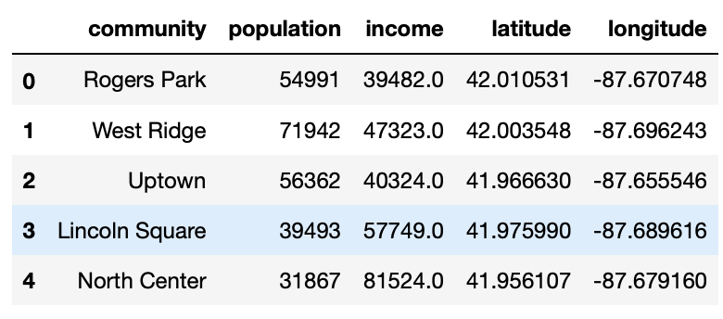

To be more vivid, I visualize geographic details of Chicago Community with the help of folium library.

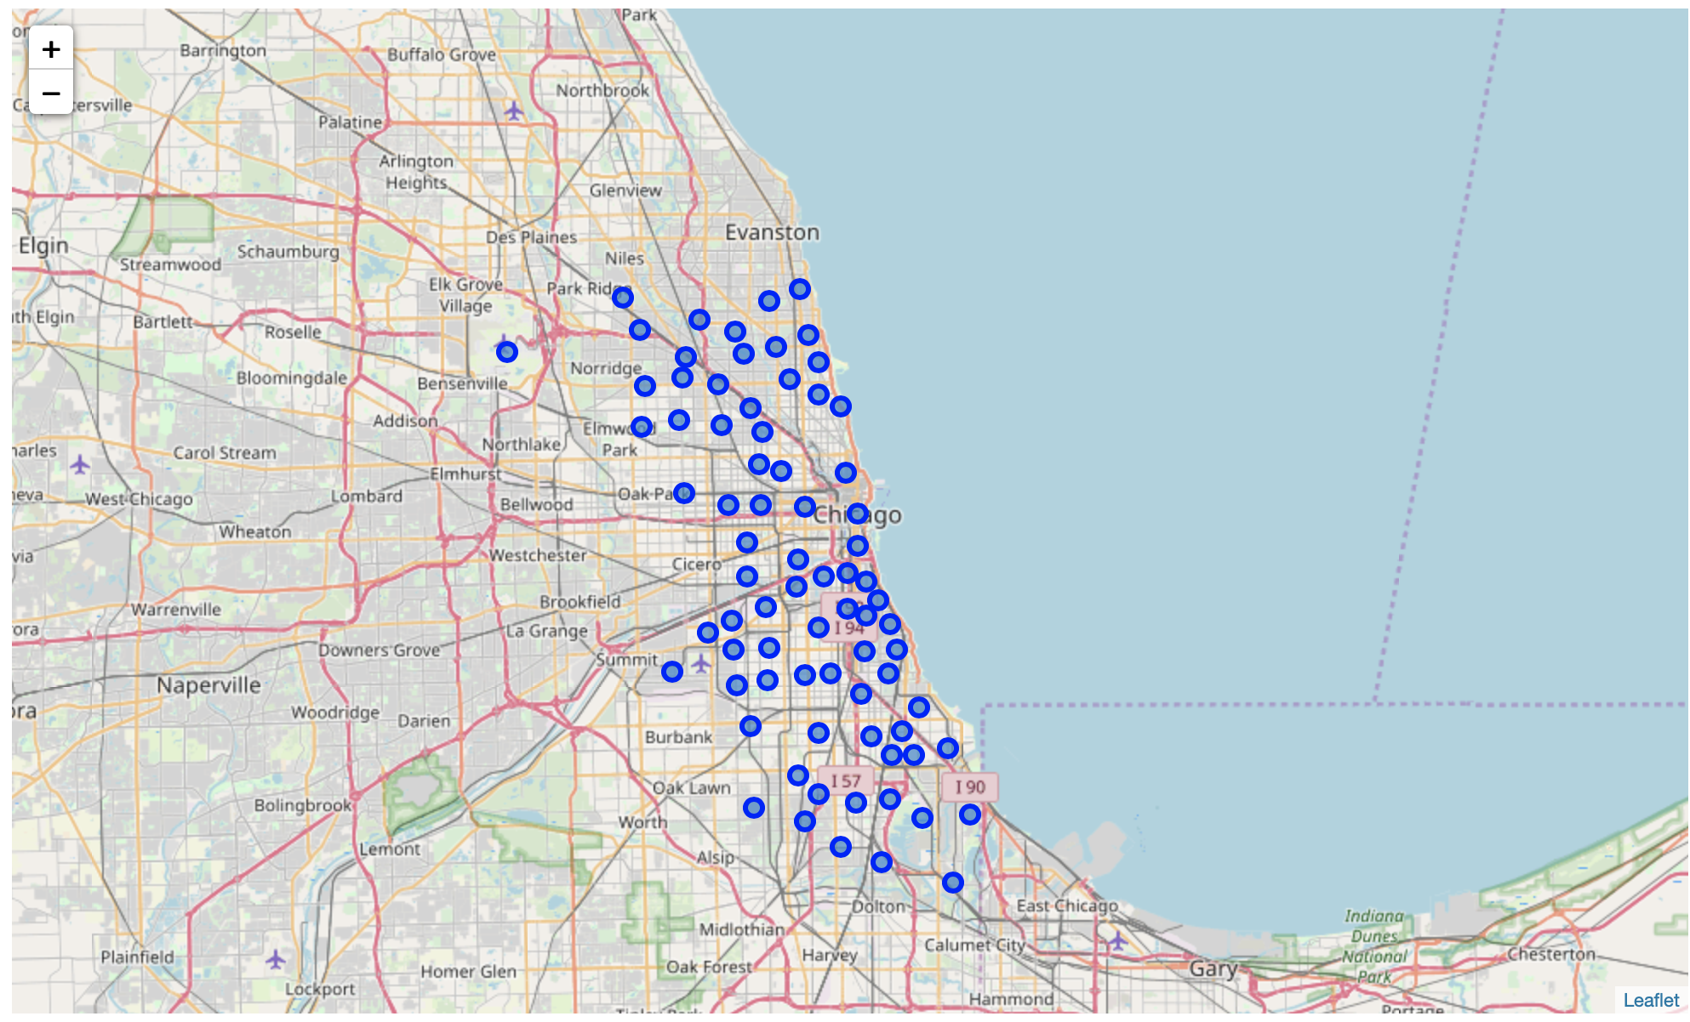

I utilized the Foursquare API to explore the community. I also design the limit as 100 restaurants and radius 1000 meters for each community from their given latitude and longitude information. Here is the head of the result after merged with the original community data.

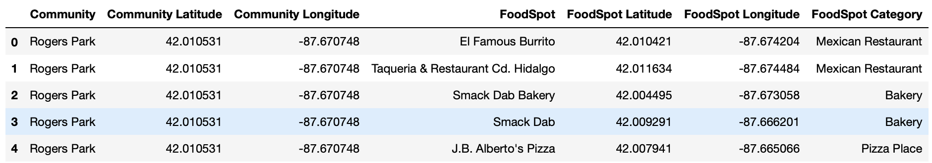

From the above table, I got that there are 2821 food spots, belonging to 96 categories. I also visualized the distribution of all the food spots by bar plot and map plot.

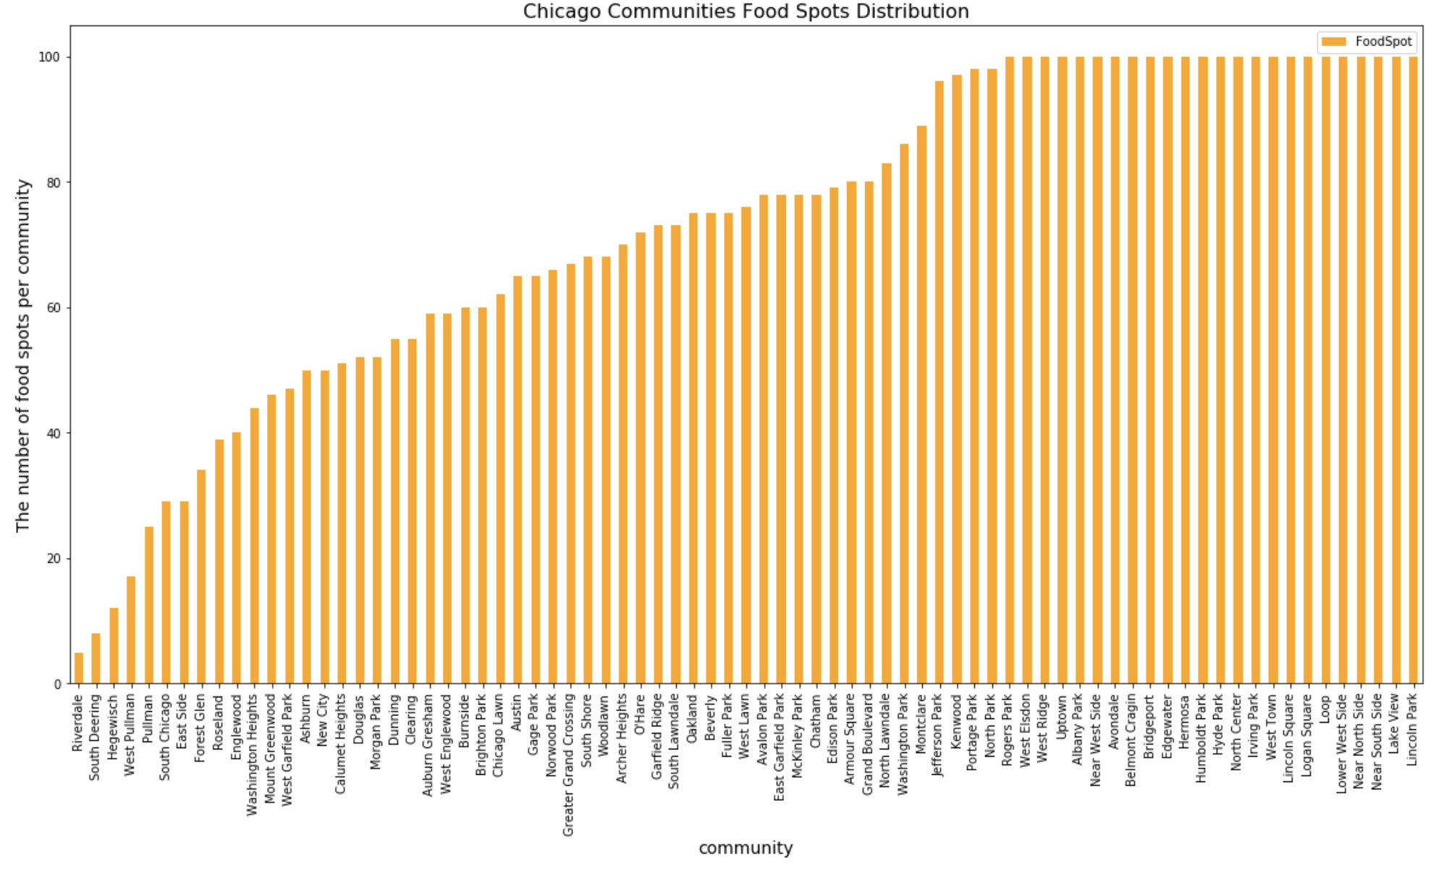

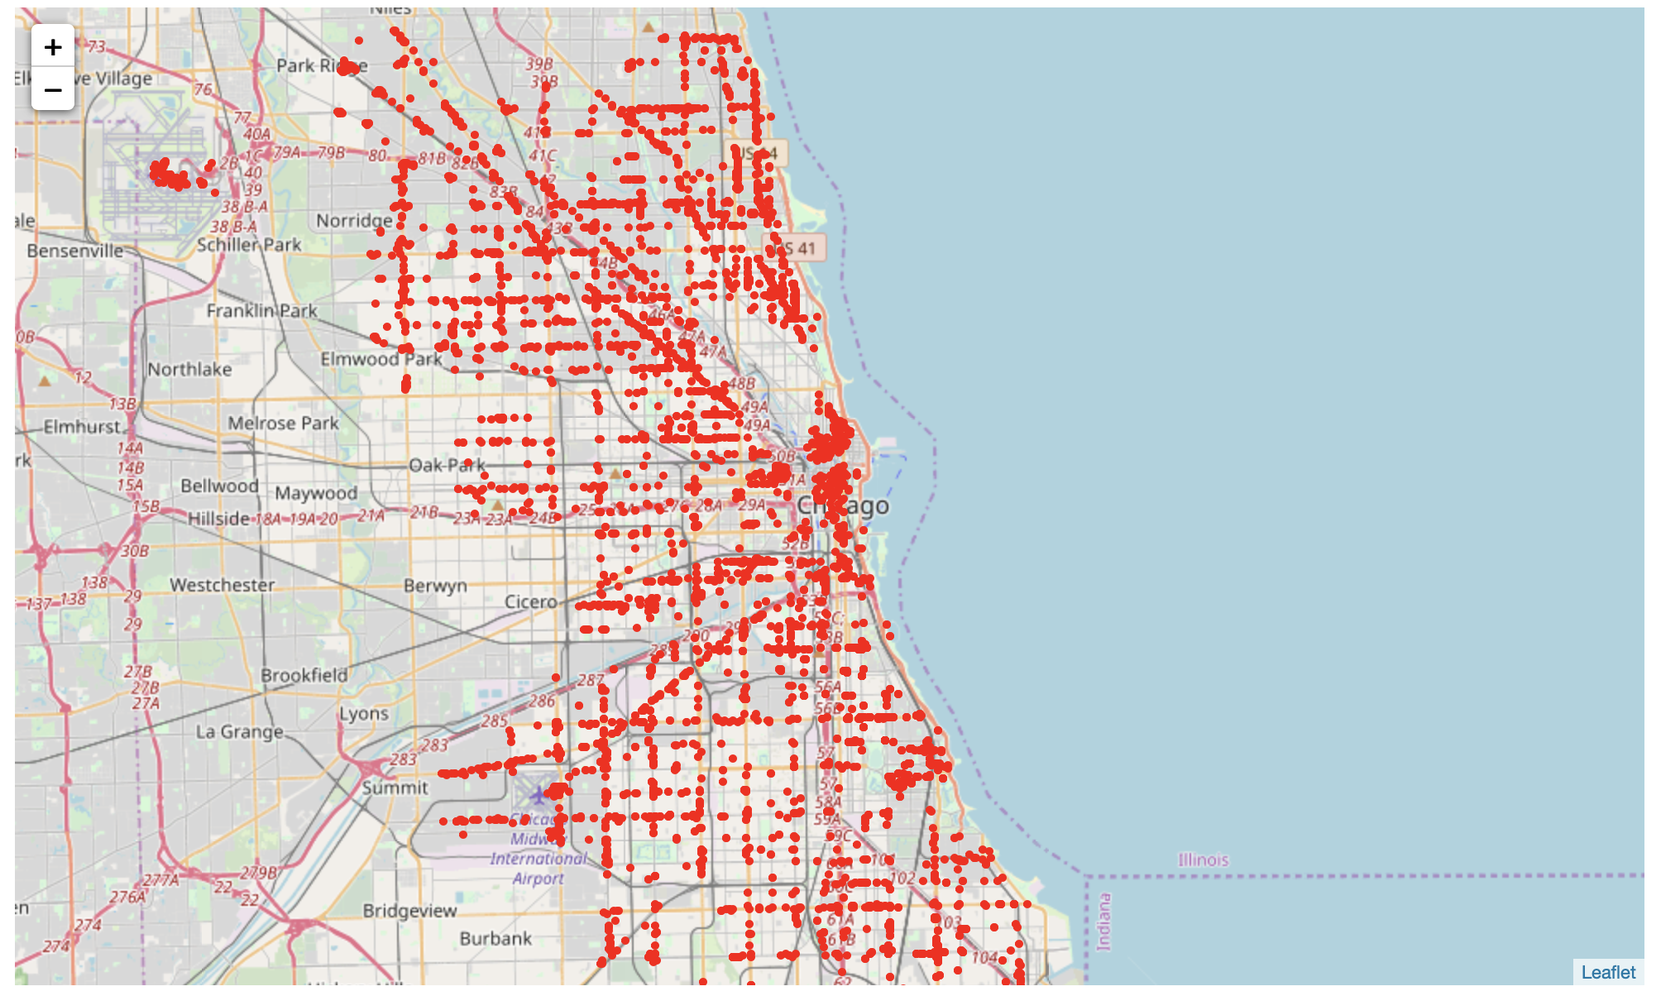

We can find that communities, like Lincoln Park, Lake View, Logan Square etc., have reached the upper limit 100 food spots. These communities locate near the coast.

The result doesn’t mean that inquiry run all the possible results in communities. Actually, it depends on given Latitude and Longitude information and here is we just run single Latitude and Longitude pair for each borough. We can increase the possibilities with more Latitude and Longitude information.

In summary of 96 restaurant categories returned by Foursquare, I created a table which shows a list of top ten restaurant categories for each community below.

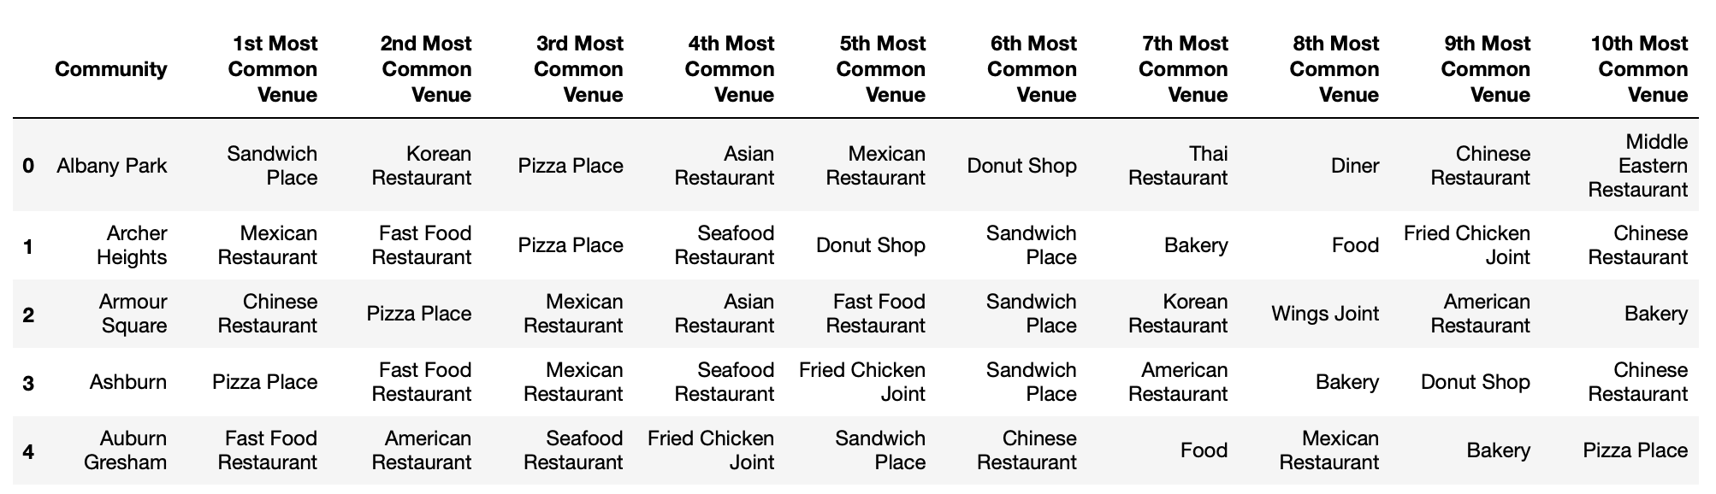

I noticed that there are some categories in common. In this reason, I used unsupervised machine learning k-means algorithms to cluster communities. K-Means algorithm is one of the most common cluster methods of unsupervised learning.

To find the optimal k of k-means algorithm, I analyze the k-means with elbow method. After that, it shows that k = 4 will be the optimal solution.

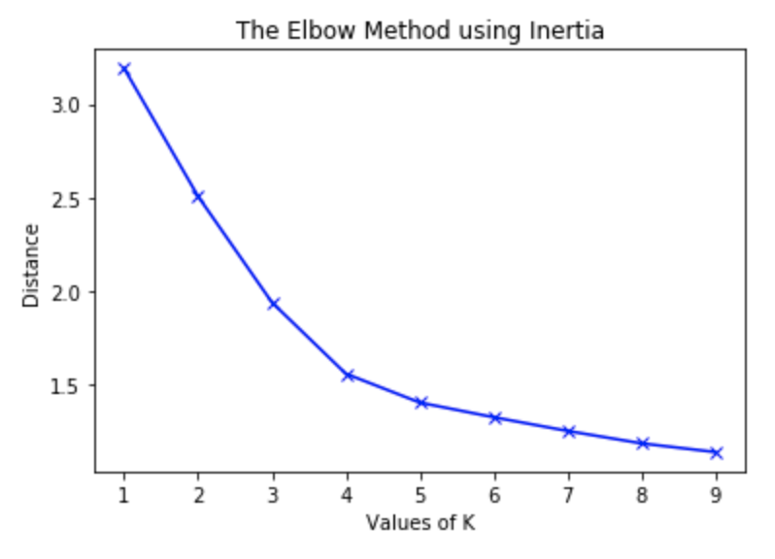

Here is the merged table with cluster label for each community.

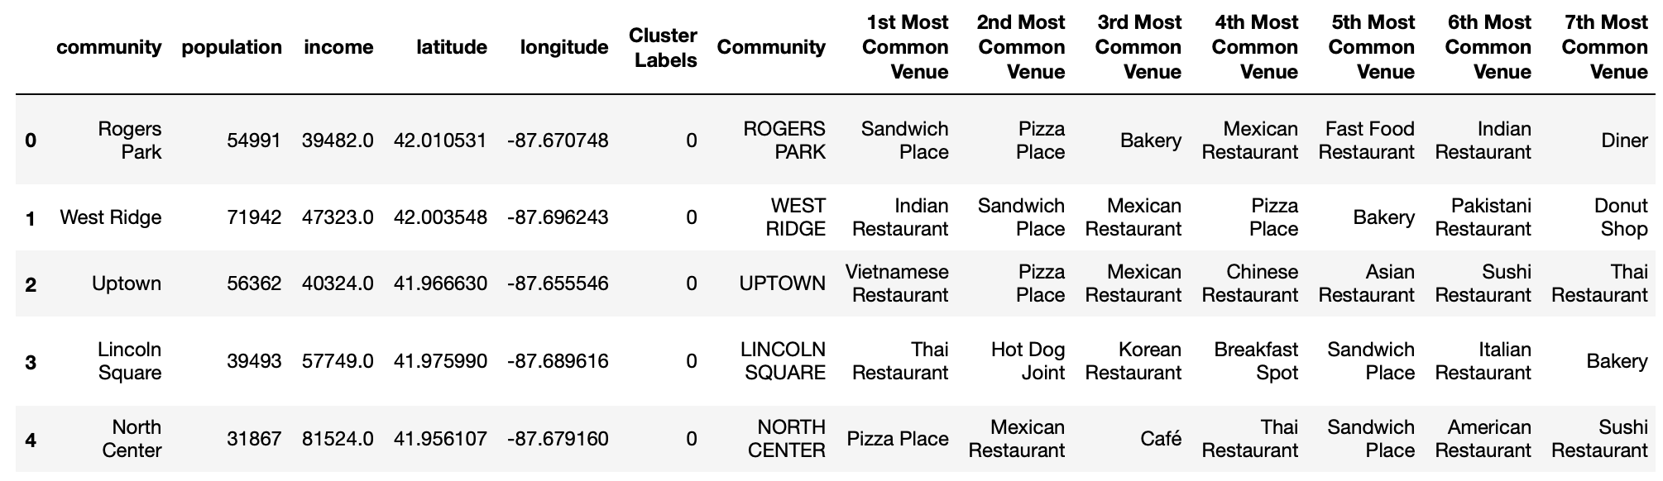

I also visualized the number of **1st Most Common Venue** in each cluster. Thus, i can create a bar chart which may help us to find proper labels for each cluster.

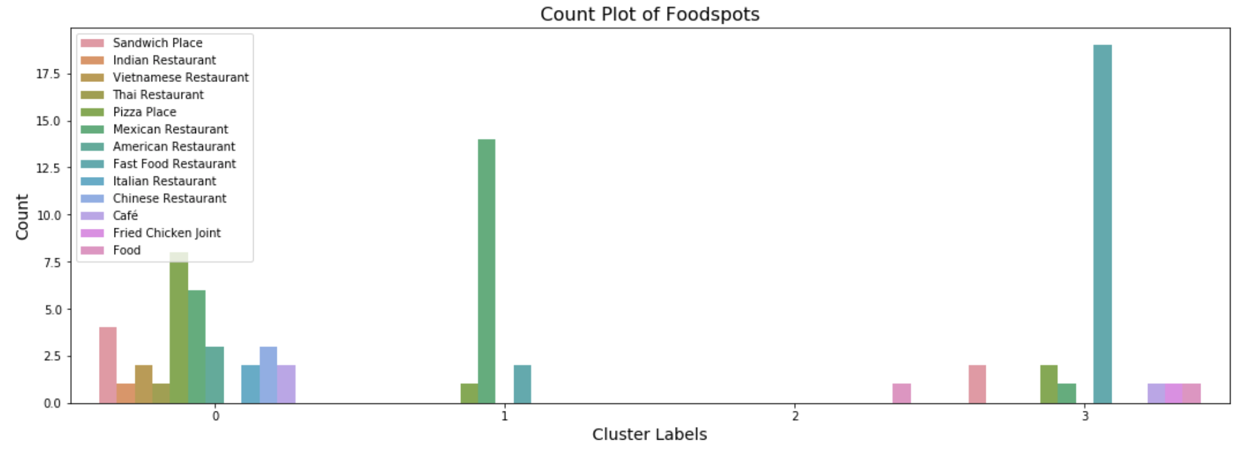

When we examine above graph, we can label each cluster as follows:

* Cluster 0: Pizza Place, Mexican Restaurant, Chinese Restaurant (various) -> **red circle**
* Cluster 1: mainly Mexican Restaurant -> **purple circle**
* Cluster 2: little restaurant -> **blue circle**
* Cluster 3: Mainly fast food -> **green circle**

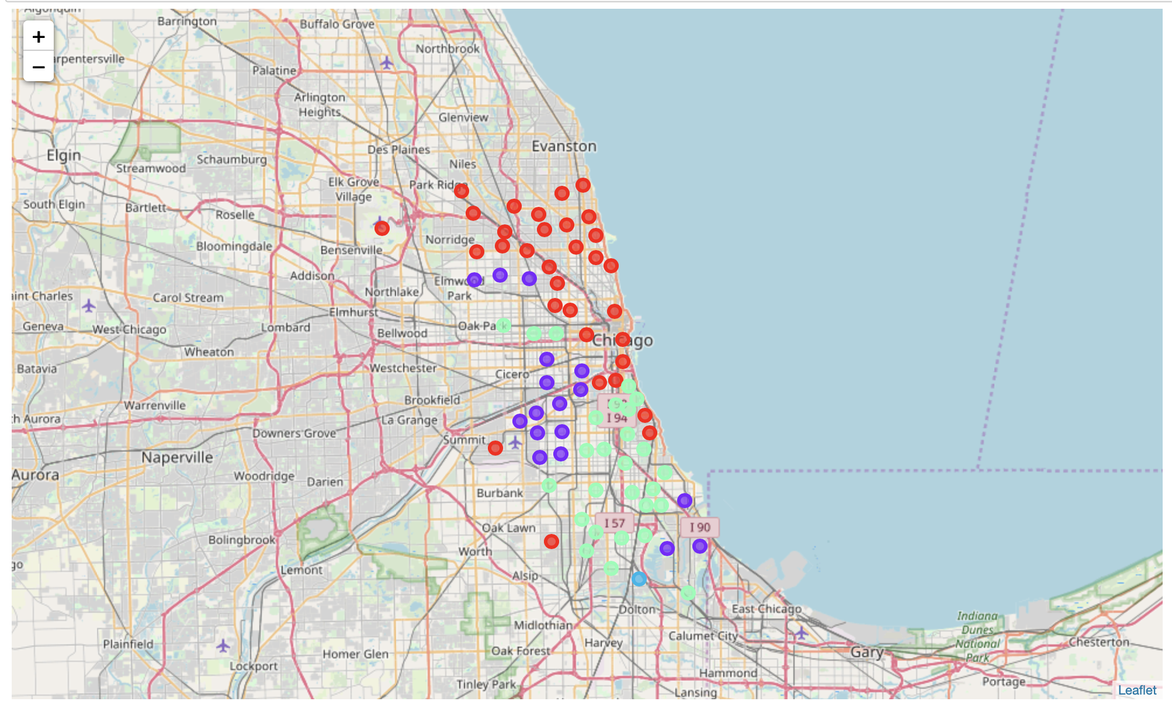

Now, I’m going to take average population per community into consideration. I plot the choropleth map below.

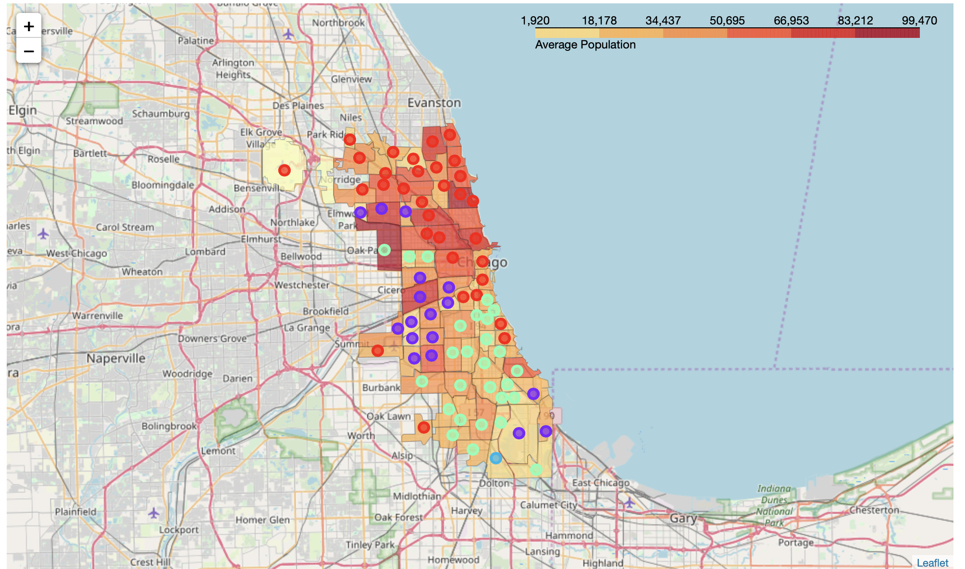

And also, I plot the choropleth map to show the average income spatial distribution.

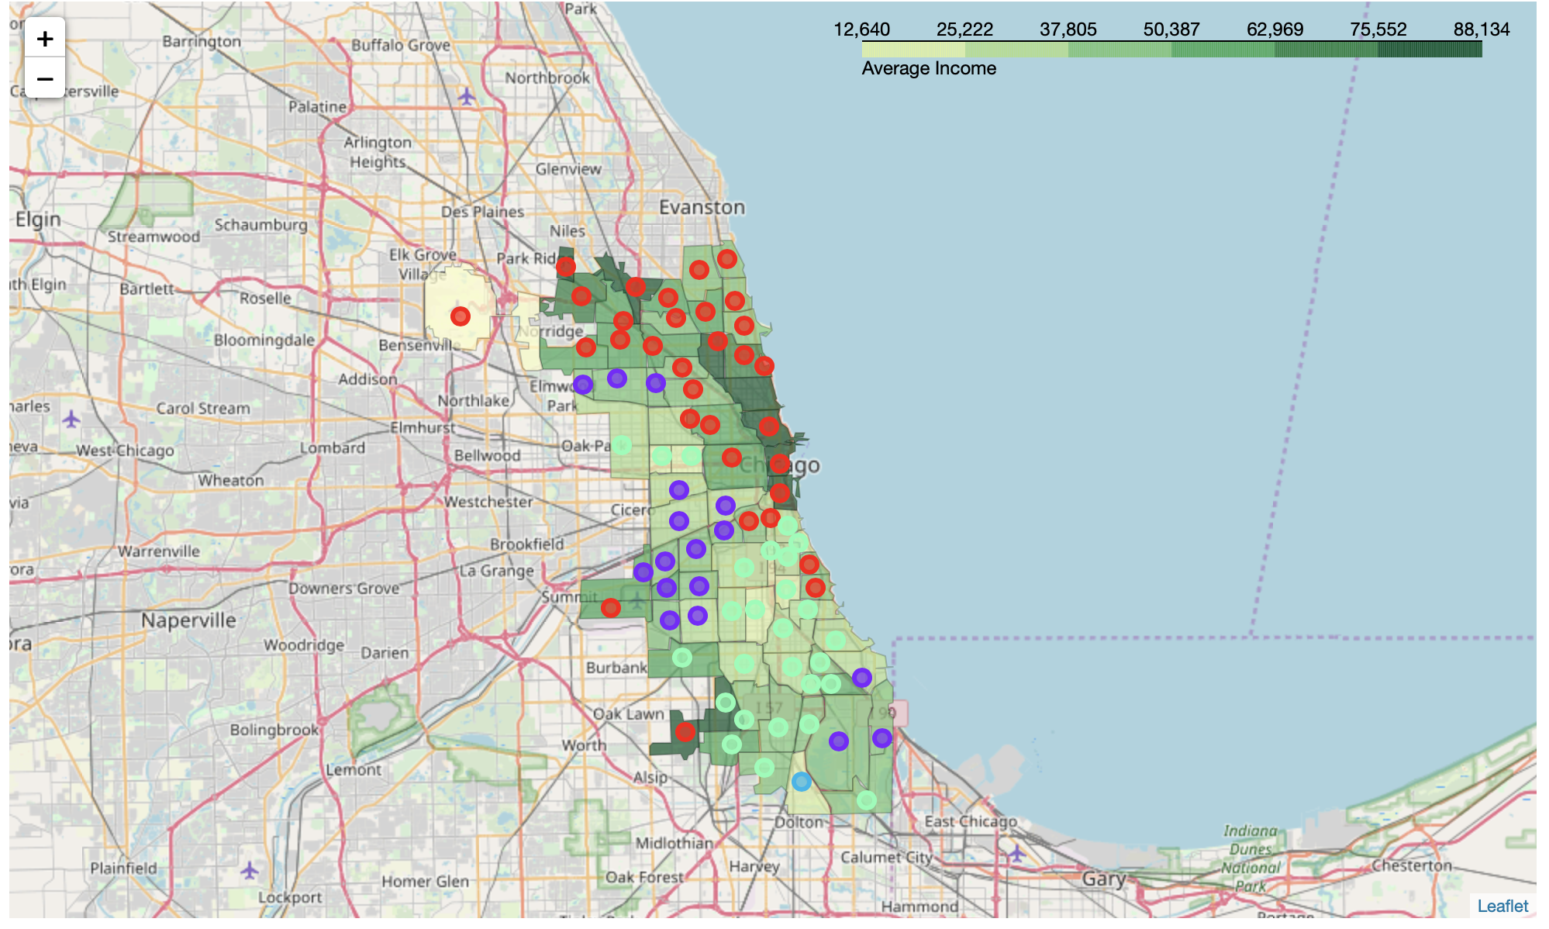

1. **Result and Discussion**

From above analysis, we can find that restaurant clusters are Fan-shaped distribution. The upper part is mainly Pizza Place, Mexican Restaurant, American Restaurant and Chinese Restaurant. The middle part is mainly Mexican Restaurant. And the lower part is mainly fast food.

From the income choropleth map, we can probably find the reason. The upper part area has higher income and lower part has lower income. I think this can explain why there are so many fast food restaurants in the lower part communities and why there are various restaurant options in the upper part communities.

1. **Conclusion**

As I mentioned at the beginning, Chicago is a popular city with 77 communities and large population. There are tons of business opportunities. This project will give you a good start to analysis. More specifically, if you want to set up a restaurant in Chicago, you should clear about your budgets, your target customer, your style of restaurant, etc. Then we can dig more information and do more specific analysis based on this project.

1. **References**

* [1] [Chicago Wikipedia](https://en.wikipedia.org/wiki/Chicago)
* [2] [CMAP – Chicago Community Data Snapshots](https://www.cmap.illinois.gov/data/community-snapshots)
* [3] [gov.com – community areas](https://catalog.data.gov/dataset?q=community+&sort=views_recent+desc&organization=city-of-chicago&as_sfid=AAAAAAUBC4wk6ma3Iqk2fusL-1yAGxEP_nD27-M4crD3Bf87SOmLWWvkOFw3ICL2xEHcxoM-PvxQ0uWpGdUz5RZfkqQAQUpUMqxspcVcxlhd5K3LPIN7qnKHmBTlw5l2DaOeVMk%3D&as_fid=d64462f56ec830d29660b9e4a41c2b417cee07c5&ext_location=&ext_bbox=&ext_prev_extent=-142.03125%2C-8.05922962720018%2C-59.0625%2C52.696361078274485)
* [4] [Foursquare API](https://developer.foursquare.com/)
* [5] [GeoPy API](https://geopy.readthedocs.io/en/stable/)
* [6] [My Github](https://github.com/shao-hua-zhang)